Module 1 Project Planning and Organization – Unit 2 Procurement Strategies
- To update the generated outline, right/two-finger click over the outline area, select Update Field > Update entire table > OK
- To jump to a section click that section’s page number in the outline

1.2.1 Design-Bid-Build 3
Design-Bid-Build 3
Design-Bid-Build Explanation 4
Design-Bid-Build Divergent Project Objectives 5
Design-Bid-Build Advantages and Disadvantages 7
Design-Bid-Build During Construction 9
1.2.2 Fast Track 10
Fast Track 10
1.2.3 Construction Management 11
Construction Management 11
Construction Management Details 13
Construction Management Advantages and Disadvantages 14
1.2.4 Design-Build 16
Design-Build 16
Design-Build Advantages and Disadvantages 18
Design-Build Proposal Process 20
Design-Build Honorarium 21
Design-Build Honorarium Example 22
Design-Build Evaluation of Proposals 23
Design-Build Negotiations and Award 24
Design-Build Examples 26
1.2.5 Public Private Partnership 27
Public Private Partnership 27
Comparison of PPP and Traditional Procurement 29
Innovation in PPP 30
1.2.6 Alliancing 31
Alliancing 31
Alliancing Details 32
Alliancing Examples 33
Alliancing Lessons Learned from Successes 34
Alliancing Lessons Learned from Failures 35
1.2.7 Speculative Development 36
Speculative Development 36
1.2.8 Formative Assessment? 37
Formative Assessment? 37

1.2.1 Design-Bid-Build

Design-Bid-Build

Slide # | 10 | Content Slide
Slide Type | Content | 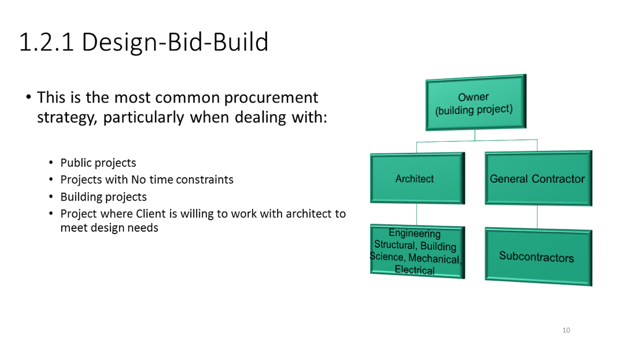
Storyline Text
Design-Bid-Build

- Most common procurement strategy

- Public projects
- Projects with no time constraints
- Building projects
- Project where client is willing to work with architect
Storyline Visuals/Animation |  | Storyline Interactivity
- Design-Bid-Build project management structure graphic
Voice-over Script
Design=-bid-build also known as traditional method is the most commonly used project delivery method. Particularly when dealing with, public projects, projects with no time constraints.

The theory of this process is that any qualified contractor will produce the same product from the plans and specifications, provided the plans and specifications are complete and written properly. This process treats construction like a commodity. Design the product and assume the results of the process will be identical, no matter who constructs the product.

In this type of project delivery, these three parties have separate functions and clearly defined responsibilities:
Owner: (the driving force behind the project) is responsible for funding it, providing the idea, along with general scope of the needs
Architects: The architects responsibility is to provide the owner with a design solution based on the requirements
At last Builder is responsible for executing the design and managing construction

Design-bid- build is linear or sequential in nature and has a few distinct milestones.
After the owner supplies the idea, they work with the architect to generate a clear design concept which in turn guides the design phase. During the design phase, the design party first puts together a schematic deign, which the owner then reviews and approves, then the design entity proceeds to more fully develop the design concept and preliminary specifications. At the end of the design phase and after yet another review of the owner, the architect prepares final drawings and specifications also known as “contract Documents”
During the bidding phase, the owner with perhaps the help of some professional consultants depending on the size of the job, obtains a number of competitive bids from qualified contractors (now sometimes the contractors need to be prequalified, sometimes they don’t> This would depend on the preference of the owner and size and complexity of the project.
The owner then reviews the bids, and doesn’t need to choose the lowest bidder, but can instead use the combination of price and builder competence.
When the design phase is completed, bidding takes place, where a contractor is selected who later builds the project.
This is a method where the owner forms separate contracts with the design party and the construction party or the general contractor. The general contractor can then form contracts with specialized subcontractors to perform the work.

Questions and Comments
- I’m not certain what the project management structure is depicting. Is it the reporting structure for the project? Other? Please let me know so that I can adjust the script, or feel free to make changes yourself.

Design-Bid-Build Explanation

Slide # | 11 | Content Slide
Slide Type | Content | 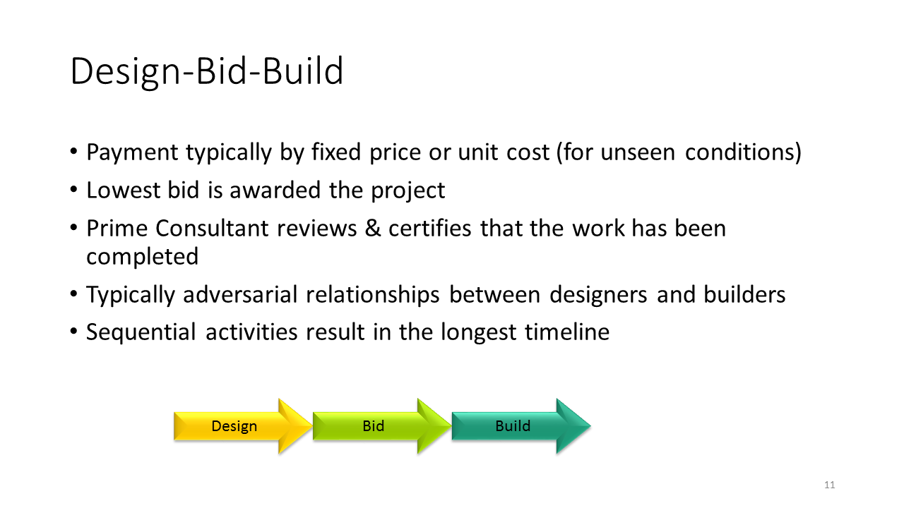
Storyline Text
- Payment typically by fixed price or unit cost
- Lowest bid, or a combination of the bid price and contractor competency, is used to award the project
- Sequential activities result in longest timeline
Storyline Visuals/Animation |  | Storyline Interactivity
- Design, bid, and build arrows
Voice-over Script
In the Design-Bid-Build procurement strategy, payment is typically arranged by fixed price or unit cost. The lowest bid, or a combination of the bid price and contractor competency, is awarded the project.

The sequential order of the procurement activities in Design-Bid-Build results in the longest timeline of the procurement strategies. The design phase must be complete before the bid phase, which must be complete before the building phase. In this strategy, there is also typically an adversarial relationship between the designers and builders.
Questions and Comments

Design-Bid-Build Divergent Project Objectives

Slide # | 12 | Content Slide
Slide Type | Content | 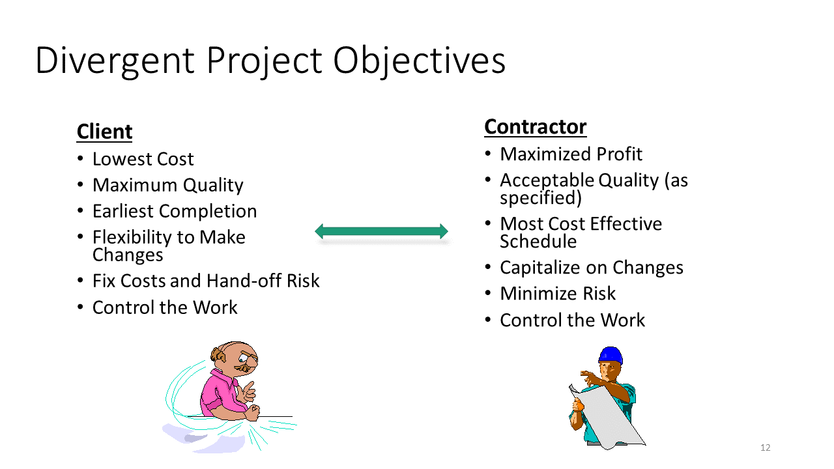
Storyline Text
Divergent Project Objectives
 | Client | Contractor
Cost | Lowest cost | Maximized profit
Quality | Maximum quality | Acceptable quality (as specified)
Schedule | Earliest completion | Most cost-effective schedule
Changes | Flexibility to make changes | Capitalize on changes
Risk | Fix costs and hand-off risk | Minimize risk
Control | Control the work | Control the work

Storyline Visuals/Animation |  | Storyline Interactivity
- Visual of client and visual of contractor  - Sync animation of the table of project objectives with the script |  | Instead of just saying/showing the divergent objectives, could provide them in an ungraded drag-and-drop activity where students have to decide if an objective belongs to a client or a contractor  - Could show one item at a time and provide feedback after each one is placed  - Could also provide a skip/show solution option (which would be quicker for when students are reviewing the module)
Voice-over Script
The adversarial relationship is caused by divergent project objectives between the client and the contractor.

Script Option 1: All client, then all contractor
The client wants the lowest cost for the maximum quality at the earliest possible completion, while maintaining the flexibility to make changes and the ability to fix costs and hand-off risk, and controlling the work. In contrast, the contractor wants to maximize profit while achieving an acceptable specified quality, following a cost effective schedule, maintaining the ability to capitalize on changes, minimizing risk, and controlling the work.

Script Option 2: Each point in order for both client and contractor
…when it comes to cost, quality, schedule, changes, risk, and control.
While the client is aiming for the lowest cost, the contractor is interested in maximizing profit.
The client’s goal maximum quality, but the contractor’s goal is the acceptable quality specified in the project.
The client is interested in the earliest project completion date, while the contractor wants to follow the most cost-effective schedule.
The client wants the flexibility to make changes throughout the project, but the contractor wants to be able to capitalize on any changes that are made.
While the client wishes to fix costs and hand-off risk, the contractor aims to minimize risk.
Finally, both the client and the contractor want to control the work.
Questions and Comments
- Two script options (see above):
  - Script Option 1: All client, then all contractor
  - Script Option 2: Each point in order for both client and contractor

Design-Bid-Build Advantages and Disadvantages

Slide # | 13 | Content Slide
Slide Type | Content | 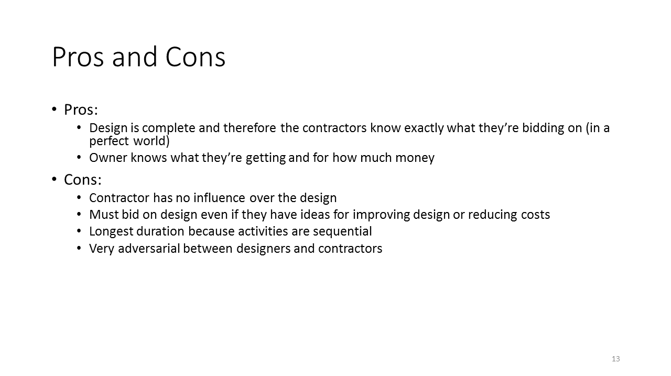
Storyline Text
Advantages
- Contractors know what they are bidding on
- Owners know what they are getting

Disadvantages
- Contractor has no influence over design
- Contractor must bid on design as-is
- Longest procurement duration because activities are sequential
- Adversarial relationship between designers and contractors
Storyline Visuals/Animation |  | Storyline Interactivity
Instead of just saying/showing the pros and cons, could provide them in an ungraded drag-and-drop activity where students have to decide if an item is to a pro or a con (though maybe only if not done in the divergent project objectives slide previously)
- Could show one item at a time and provide feedback after each one is placed
- Could also provide a skip/show solution option (which would be quicker for when students are reviewing the module)
Voice-over Script
There are a number of advantages and disadvantages to the Design-Bid-Build procurement strategy.

Because the design is completed ahead of time, an advantage is that the contractors know exactly what they are bidding on, while the owners know what they are getting and for what price.

The disadvantages are that the contractor has no influence over the design and they must bid on the design as-is, even if they have ideas for improvement or for reducing costs. The Design-Bid-Build strategy also has the longest procurement duration because the activities are sequential. Finally, the relationship between designers and contractors is very adversarial.
Questions and Comments
- Possible to change pros and cons to advantages and disadvantages (or other?) to maintain consistency of language throughout the unit?

Design-Bid-Build During Construction

Slide # | 14 | Content Slide
Slide Type | Content | 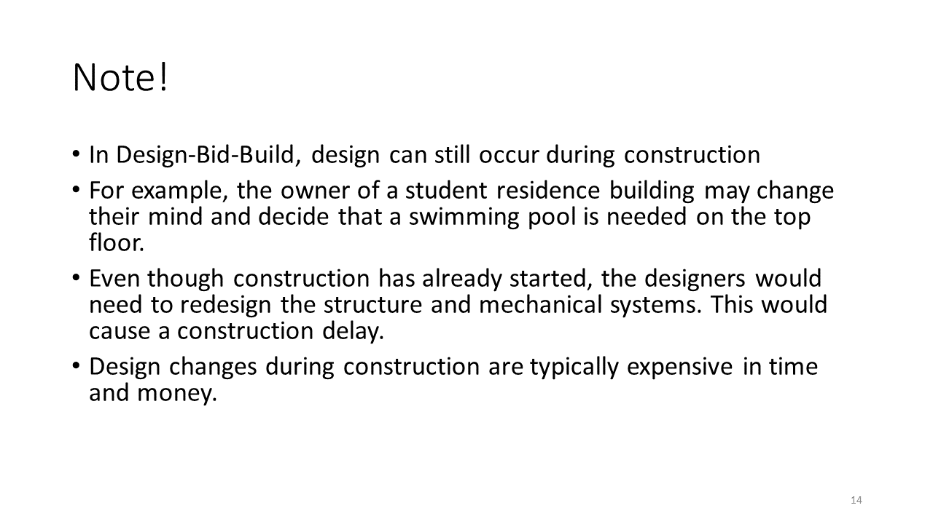
Storyline Text
- Design can still occur during construction
- Design changes during construction are expensive in time and money
Storyline Visuals/Animation |  | Storyline Interactivity
- Graphics depicting the example of changes during construction
Voice-over Script
It is important to note that in Design-Bid-Build, design changes can still occur during the construction phase. For example, the owner of a student residence building may change her mind and decide that a swimming pool is needed on the top floor (although some of us who have lived in student residences might argue it’s a bad idea!). Even though construction has already started, the designers would need to redesign the structure and mechanical systems. This would cause a construction delay. Design changes during construction are typically expensive in time and money.
Questions and Comments

1.2.2 Fast Track

Fast Track

Slide # | 15 | Content Slide
Slide Type | Content | 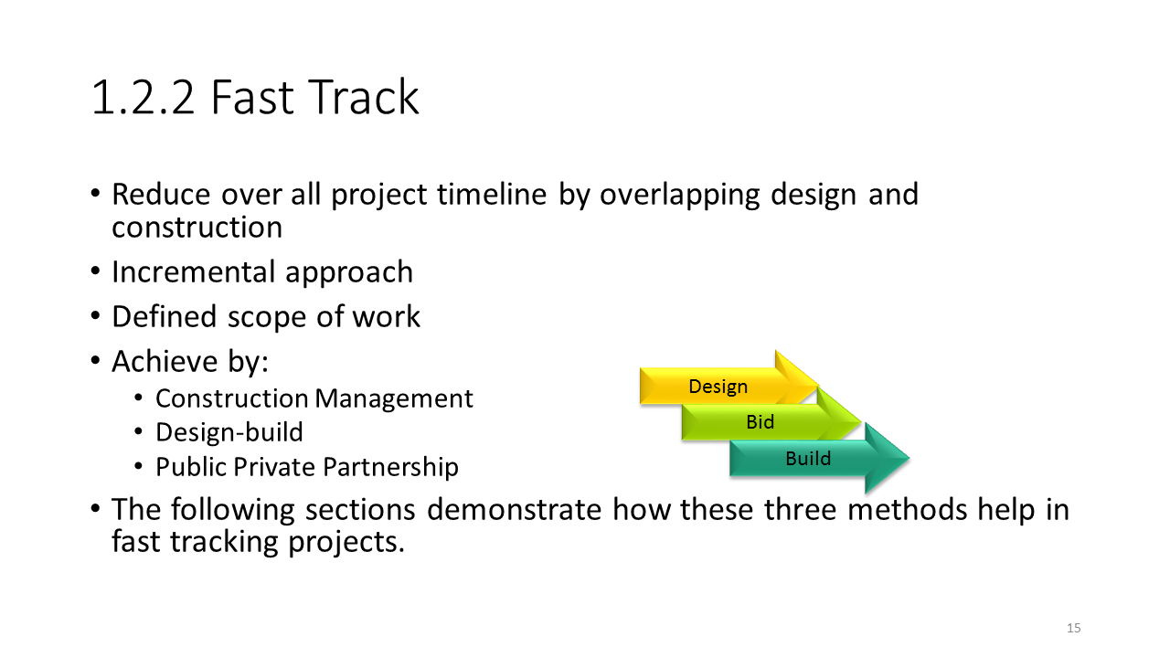
Storyline Text
Fast Track

Construction Management
Design-Build
Public Private Partnership
Storyline Visuals/Animation |  | Storyline Interactivity
- Overlapping design, bid, build arrows |  | Possible option:  Student can select to learn about Construction Management, Design-Build, or Public Private Partnership and return to this slide after the selected path is complete (if order is not important)
Voice-over Script
In contrast to Design-Bid-Build, Fast Track procurement strategies reduce the overall project timeline by overlapping design and construction. It is an incremental approach, and is defined by the scope of the work. Fast Track is achieved through a number of procurement options, including: Construction Management, Design-Build or Public Private Partnership. The following sections demonstrate how these three methods help in fast tracking projects.
Questions and Comments
Very unclear what the “achieve by” points mean and if the chart on the right corresponds to the words they are aligned with.

1.2.3 Construction Management

Construction Management

Slide # | 16 | Content Slide
Slide Type | Content | 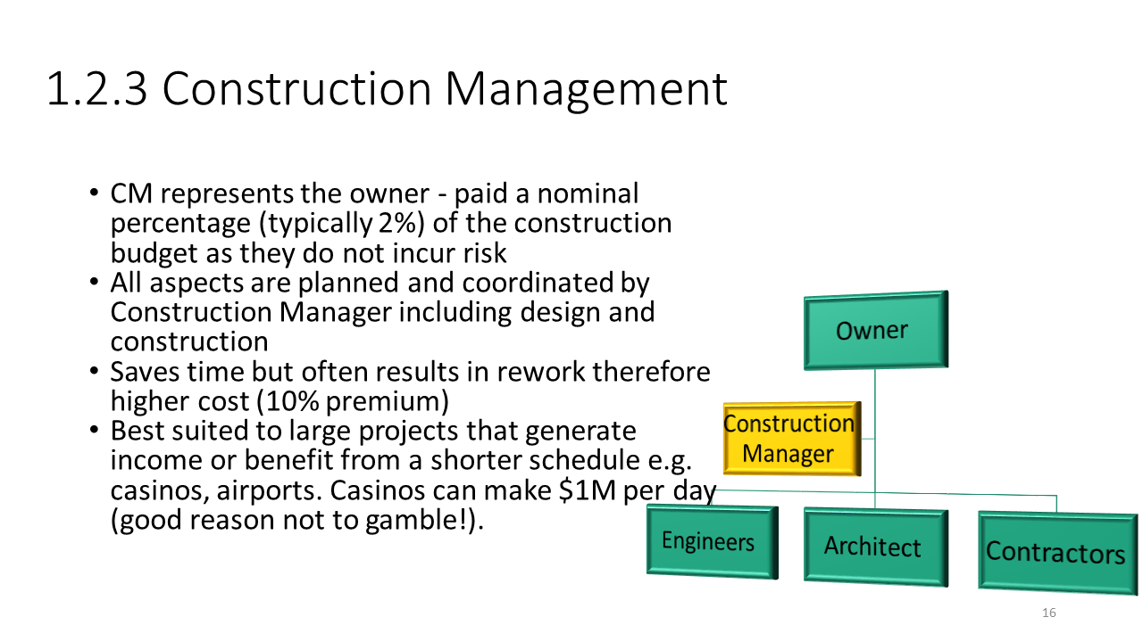
Storyline Text
Fast Track – Construction Management

- Construction Manager (CM) represents the owner
- All aspects of project planned and coordinated by CM
- Strategy saves time but often results in rework and higher costs
- Best suited to large projects that generate income or benefit from earlier completion
Storyline Visuals/Animation |  | Storyline Interactivity
- Construction management project management structure diagram
- Casino photo or icon? Airport photo or icon?
Voice-over Script
The first Fast Track procurement strategy that we are going to look at is called Construction Management. The Construction Manager represents the project owner, and is paid a nominal percentage, which is typically 2 percent, of the construction budget as they do not incur risk. All aspects of the project are planned and coordinated by the Construction Manager, including both design and construction. This strategy saves time but often results in rework, and therefore higher costs, such as a 10% premium. Construction Management is best suited to large projects that generate income or that benefit from earlier completion, such as casinos and airports. For example, casinos can make one million dollars per day, so they can quickly recover any extra costs incurred during construction as a result of a fast-track project.

In the Construction Management strategy, the owner is at the top of the project management structure. The Construction Manager acts as a link between the owner and the Engineers, Architect, and Contractors at the next level.
Questions and Comments
- Unclear if the 10% premium is a set expectation for every project or if it is just an example
- Again, I’m not certain what language to use when explaining the project management structure (see comment for Design-Bid-Build hierarchy above)

Construction Management Details

Slide # | 17 | Content Slide
Slide Type | Content | 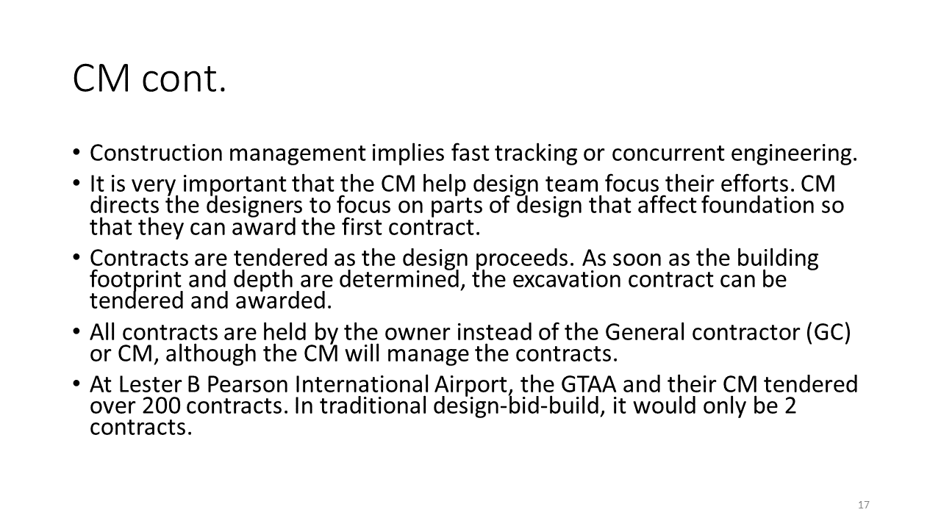
Storyline Text
- CM implies fast tracking or concurrent engineering
- The CM helps the design team focus their efforts
- Contracts are tendered as the design proceeds
- All contracts are held by the owner
Storyline Visuals/Animation |  | Storyline Interactivity
- Photo of Lester B. Pearson International Airport
Voice-over Script
Construction Management implies fast tracking or concurrent engineering.

It is very important that the Construction Manager help the design team focus their efforts. For example, the Construction Manager can direct the designers to first focus on parts of the design that affect the foundation of a building so that they can award the foundation contract first and get that activity started. .

All contracts are held by the owner instead of the General Contractor or Construction Manager, even though the Construction Manager will manage the contracts.

Contracts are tendered as the design proceeds. For example, as soon as the building footprint and depth are determined, the excavation contract can be tendered and awarded. This method results in a large number of contracts. For example, at Lester B. Pearson Airport in Toronto, the Greater Toronto Airports Authority and their Construction Manager tendered over 200 contracts. In a traditional Design-Bid-Build strategy, there would only have been two contracts.
Questions and Comments

Construction Management Advantages and Disadvantages

Slide # | 18 | Content Slide
Slide Type | Content | 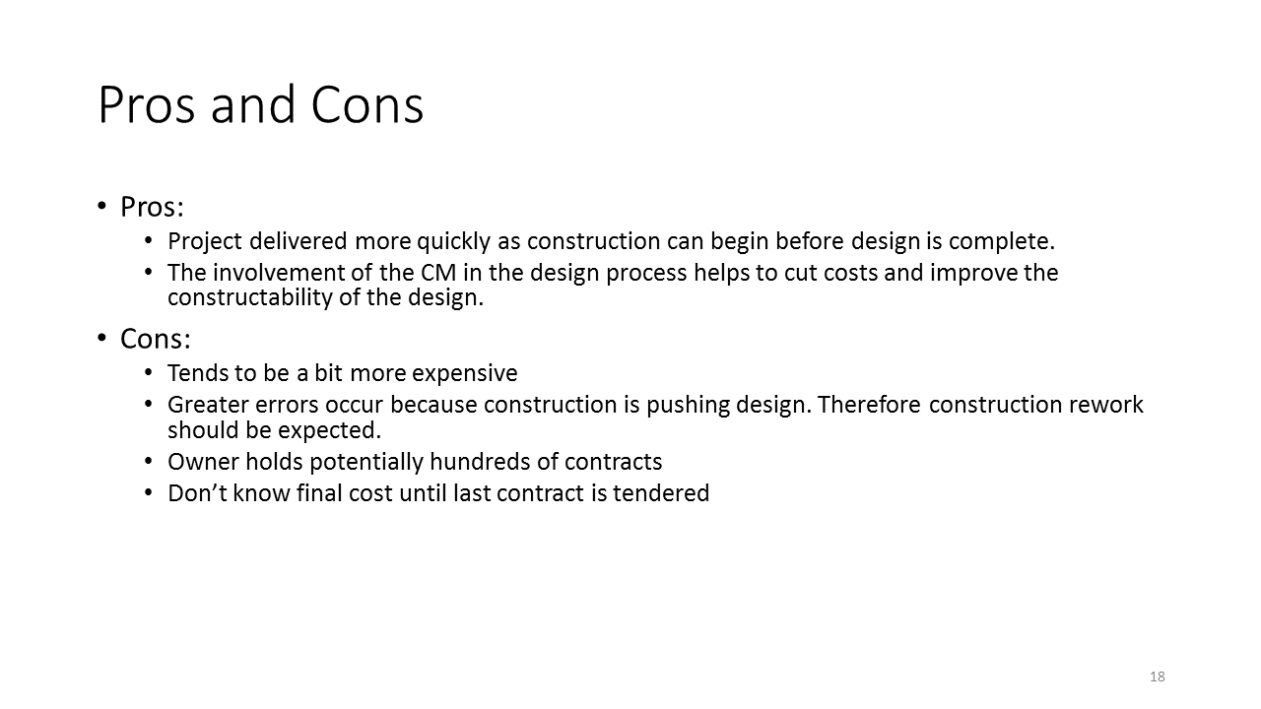
Storyline Text
Advantages
- Project delivered more quickly
- Construction can begin before design is complete
- Involvement of CM in design process helps to cut costs and improve constructability of design

Disadvantages
- Tends to be more expensive
- Greater number of errors because construction pushes design
- Construction rework should be expected
- Owner potentially holds hundreds of contracts
- Final cost of project unknown until last contract tendered
Storyline Visuals/Animation |  | Storyline Interactivity
Instead of just saying/showing the pros and cons, could provide them in an ungraded drag-and-drop activity where students have to decide if an item is to a pro or a con
- Could show one item at a time and provide feedback after each one is placed
- Could also provide a skip/show solution option (which would be quicker for when students are reviewing the module)
Voice-over Script
There are a number of advantages and disadvantages to the Construction Management procurement strategy.

One advantage is that the project will be delivered more quickly than other strategies, as construction can begin before design is complete. Another advantage is that the involvement of the Construction Manager in the design process helps to cut costs and improve the constructability of the design.

Disadvantages of the Construction Management strategy are that projects tend to be a bit more expensive, and there are a greater number of errors because construction is pushing design, meaning that construction rework should be expected. Further disadvantages are that the owner potentially holds hundreds of different contracts, and the final cost of the project is unknown until the last contract is tendered.
Questions and Comments

1.2.4 Design-Build

Design-Build

Slide # | 19 | Content Slide
Slide Type | Content | 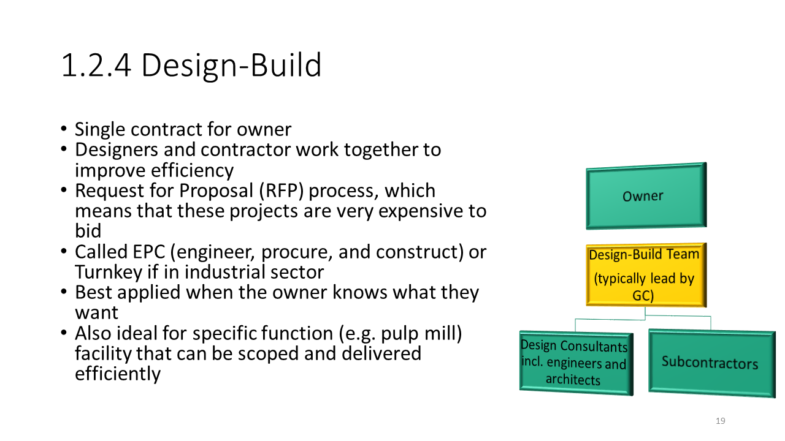
Storyline Text
Fast Track – Design-Build

- EPC (engineer, procure, construct)
- Single contract for owner
- Designers and contractor work together to improve efficiency
- Request for Proposal (RFP) process used
- Projects are expensive to bid
- Best applied when owner knows what she wants
- Ideal for specific function facilities
Storyline Visuals/Animation |  | Storyline Interactivity
- Design-build project management structure diagram
- Pulp mill photo?
Voice-over Script
The next Fast Track procurement strategy that we will look at is called Design-Build. It is also known as EPC, which stands for engineer, procure, and construct, or Turnkey if the project is in the industrial sector.

In the Design-Build strategy there is only a single contract for the owner. The designers and contractor work together to improve efficiency of the project. A Request for Proposal, or RFP, process is used, which leads to projects that are very expensive to bid. The best application of this strategy is when the owner knows what she wants. It is also ideal for specific function facilities, such as a pulp mill, that can be scoped and delivered efficiently.

In the Design-Build strategy, the owner is at the top of the project management structure, which enters into a contractual relationship with the General contractor, which would then hire and manage the contracts with the Design Consultants (including engineers and architects), and the subcontractors.
Questions and Comments
Again, I’m not certain what language to use when explaining the project management structure (see comment for Design-Bid-Build hierarchy above)

Design-Build Advantages and Disadvantages

Slide # | 20-21 | Content Slide
Slide Type | Content | 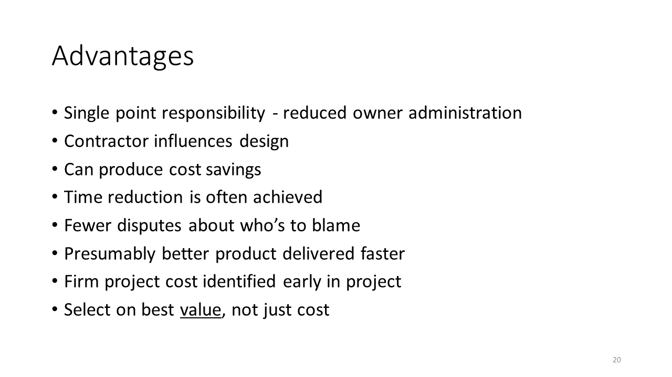  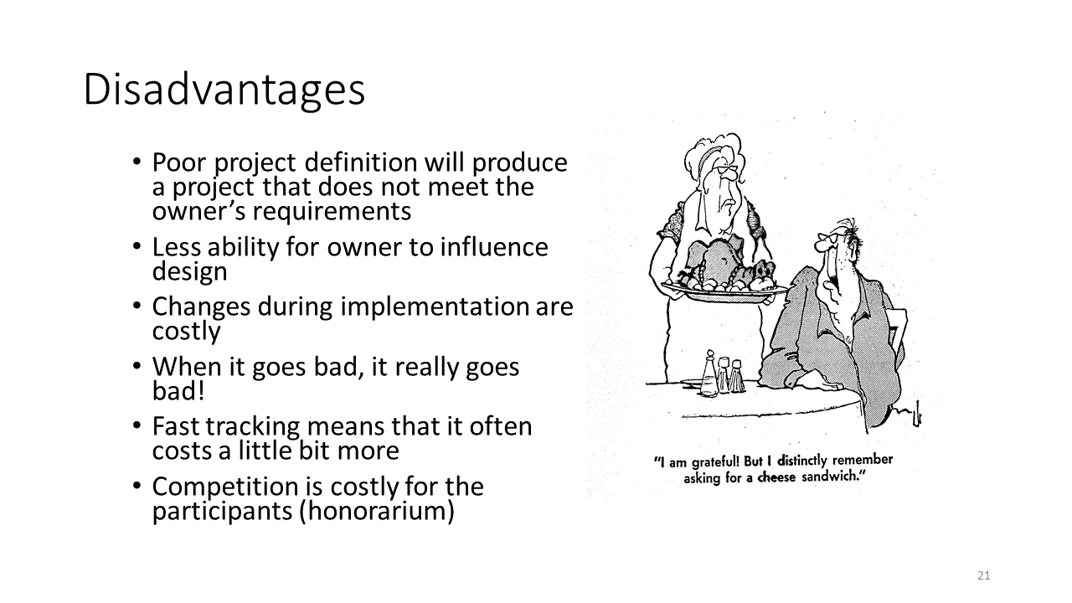
Storyline Text
Advantages
- Single point of responsibility and reduced owner administration
- Contractor influences design
- Potential cost savings and time reduction
- Fewer disputes about blame for errors
- Presumably, better product delivered faster
- Firm project costs identified early
- Design chosen on best value, not lowest overall cost

Disadvantages
- Poor project definition may produce project that does not meet requirements
- Decreased ability for owner to influence design
- High costs of changes made during implementation
- If the project goes bad, it tends to go really bad!
- Fast tracking means higher cost
- Competition in RFP process is expensive
Storyline Visuals/Animation |  | Storyline Interactivity
- Graphic depicting one party not getting what they want |  | Instead of just saying/showing the pros and cons, could provide them in an ungraded drag-and-drop activity where students have to decide if an item is to a pro or a con  - Could show one item at a time and provide feedback after each one is placed  - Could also provide a skip/show solution option (which would be quicker for when students are reviewing the module)
Voice-over Script
There are a number of advantages and disadvantages to the Design-Build procurement strategy.

One advantage is the single point of responsibility in the project, which reduces owner administration. Another advantage is that the contractor influences the design, which can produce cost savings and time reduction, and ultimately results in fewer disputes about who is to blame for errors. Presumably this strategy leads to a better product delivered faster. Further advantages are that firm project costs are identified early in the project, and the project design is chosen based on the best value, not just the lowest overall cost.

A disadvantage of the Design-Build strategy is that a poor project definition will produce a project that does not meet the owner’s requirements. Other disadvantages are the decreased ability for the owner to influence the design, and high costs of any changes made during implementation. With the Design-Build strategy, if the project goes bad, it tends to go really bad. Fast tracking means that the project often has a higher cost, and the RFP process means that competition is costly for the participants.
Questions and Comments

Design-Build Proposal Process

Slide # | 22 | Content Slide
Slide Type | Content | 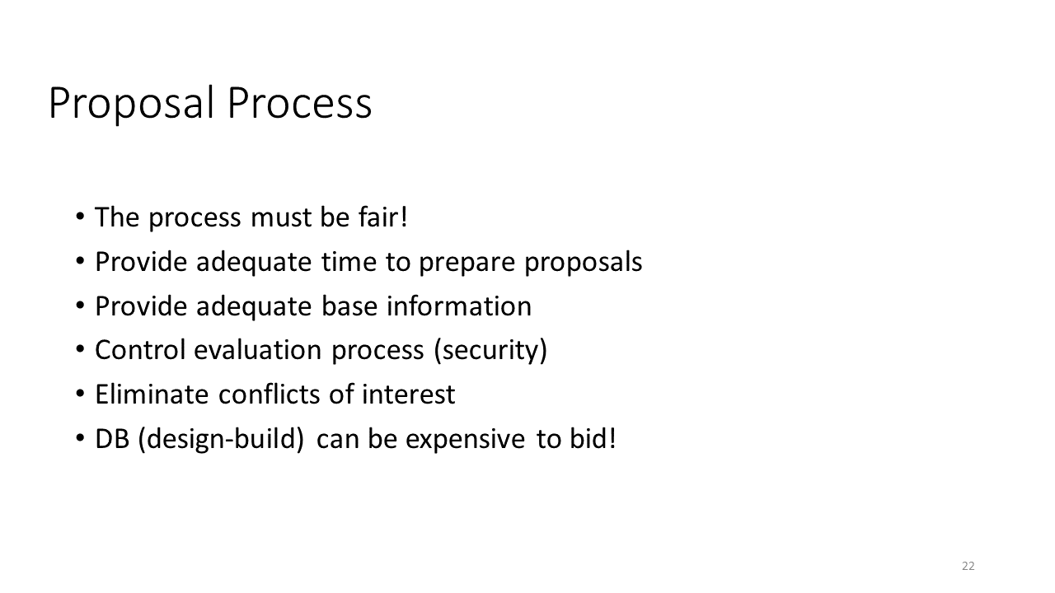
Storyline Text
Proposal Process
- Fair
- Adequate time
- Adequate base information
- Controlled and secure process
- Conflicts of interest eliminated

Design-Build projects can be expensive to bid
Storyline Visuals/Animation |  | Storyline Interactivity
Voice-over Script
The proposal process is an integral part of this strategy. The process must be fair, and bidders must be provided both adequate time to prepare proposals, and adequate base information. The evaluation process must be controlled and secure, and conflicts of interest must be eliminated. Keep in mind that Design-Build projects can be expensive to bid, as each contractor is essentially bidding on the design and construction of a project, which would be time and resource intensive to put together!
Questions and Comments

Design-Build Honorarium

Slide # | 23 | Content Slide
Slide Type | Content | 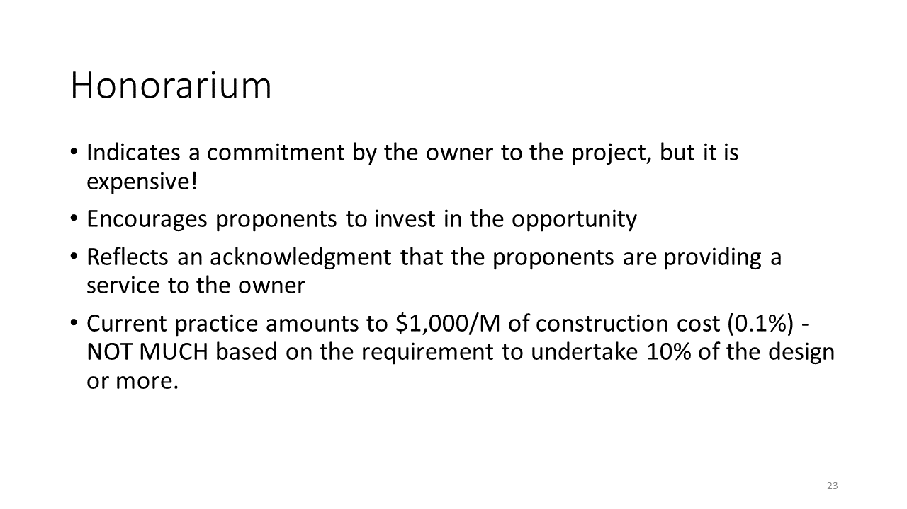
Storyline Text
Honorarium
- Indicates commitment to project by owner
- Encourages proponents to invest
- Acknowledgement that proponents are providing a service
- Current practice: $1,000/M of construction cost (0.1%)
Storyline Visuals/Animation |  | Storyline Interactivity
Voice-over Script
An honorarium indicates a commitment to the project by the owner, but it is expensive. It encourages proponents to invest in the opportunity, and it also reflects an acknowledgement that the proponents are providing a service to the owner. Current practice amounts to one thousand dollars per million dollars of construction cost, or 0.1%. This percentage isn’t much based on the requirement to undertake 10% of the design or more, so there would still be a significant commitment from the contractors to provide a bid on the project
Questions and Comments

Design-Build Honorarium Example

Slide # | 24 | Content Slide
Slide Type | Content | 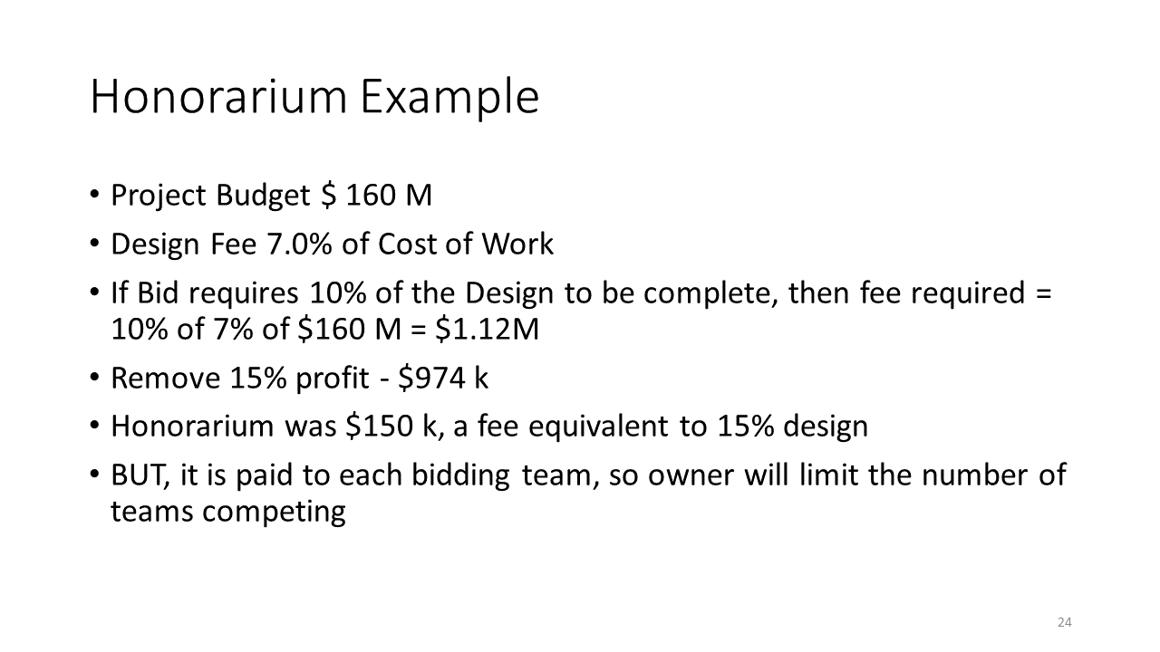
Storyline Text
Storyline Visuals/Animation |  | Storyline Interactivity
- Graphics depicting budget, design fee, amount of design, profit, and honorarium
Voice-over Script
Let’s look at an example of an honorarium. A project has a budget of 160 million dollars with a design fee of 7% of the cost of work. If the bid requires 10% of the design to be complete, then the fee required is 10% of 7% of 160 million, which is equal to 1.12 million dollars. When the 15% profit is removed, this brings us to 974 thousand dollars. The honorarium was 150 thousand, a fee equivalent to 15% of the design. Keep in mind that this is paid to each bidding team, so the owner will limit the number of teams competing.
Questions and Comments
- It isn’t entirely clear to me where all of the numbers come from. Maybe it would be beneficial to students to add a bit more information or explanation? Particularly,
  - Why a 7% design fee?
  - Why a removal of 15% profit? Where does $974 k come from?
  - Is the honorarium $150 k because it is equivalent to 15% of the design? Or is it calculated, and then happens to be about 15% of the design?
  - How many times might the owner limit the competition to?

Design-Build Evaluation of Proposals

Slide # | 25 | Content Slide
Slide Type | Content | 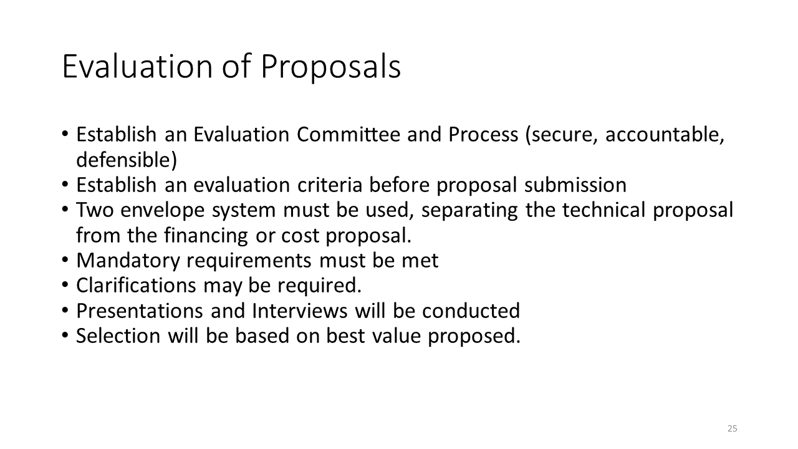
Storyline Text
Evaluation of Proposals

Process
- Evaluation committee and process
- Evaluation criteria
- Two envelope system (technical vs. financing/cost proposal)

Selection
- Mandatory requirements met
- Clarifications may be needed
- Presentations and interviews conducted
- Selection based on best value proposed
Storyline Visuals/Animation |  | Storyline Interactivity
Voice-over Script
When evaluating proposals, it is important to establish an evaluation committee and process, which must be secure, accountable, and defensible. The evaluation criteria must be established before proposal submission begins. A two envelope system must be used, separating the technical proposal from the financing or cost proposal. Proposals must meet mandatory requirements, but clarifications may be needed. Presentations and interviews will be conducted, and the final selection will be based on the best value proposed.
Questions and Comments

Design-Build Negotiations and Award

Slide # | 26-27 | Content Slide
Slide Type | Content | 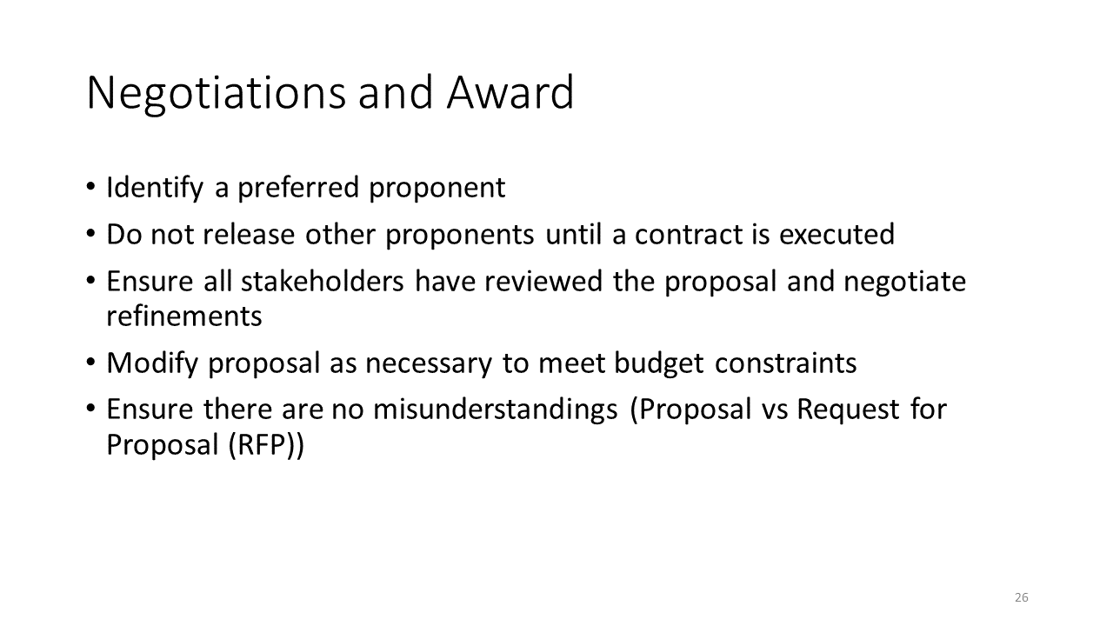  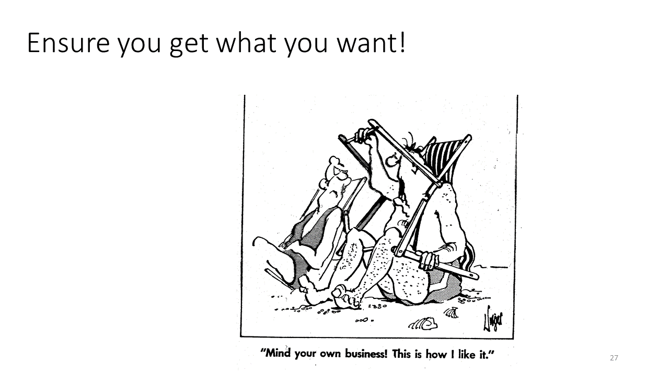
Storyline Text
Storyline Visuals/Animation |  | Storyline Interactivity
Voice-over Script
Once proposals are evaluated, and the preferred proponent is identified, negotiations can begin. Other proponents should not be released until a contract is executed. All stakeholders must review the proposal and negotiate refinements. The proposal should be modified as necessary to meet budget constraints. Before the contract is executed it is important to ensure that there are no misunderstandings between parties.
Questions and Comments

Design-Build Examples

Slide # | 28 | Content Slide
Slide Type | Content | 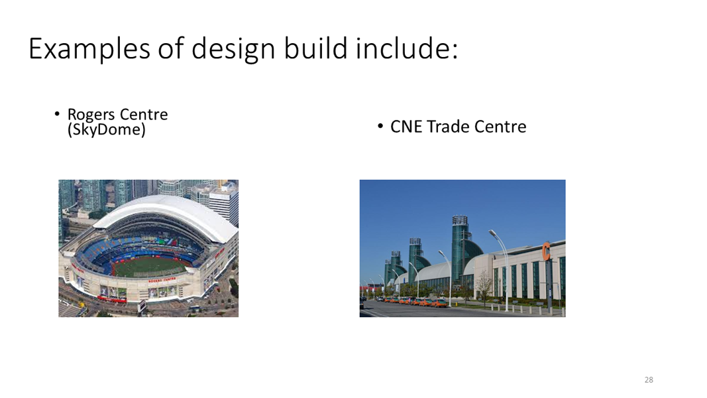
Storyline Text
Storyline Visuals/Animation |  | Storyline Interactivity
- Rogers Centre photo
- CNE Trade Centre photo
Voice-over Script
Two examples of the design-build procurement strategy are the Rogers Centre and the Canadian National Exhibition Trade Centre
Questions and Comments

1.2.5 Public Private Partnership

Public Private Partnership

Slide # | 29 | Content Slide
Slide Type | Content | 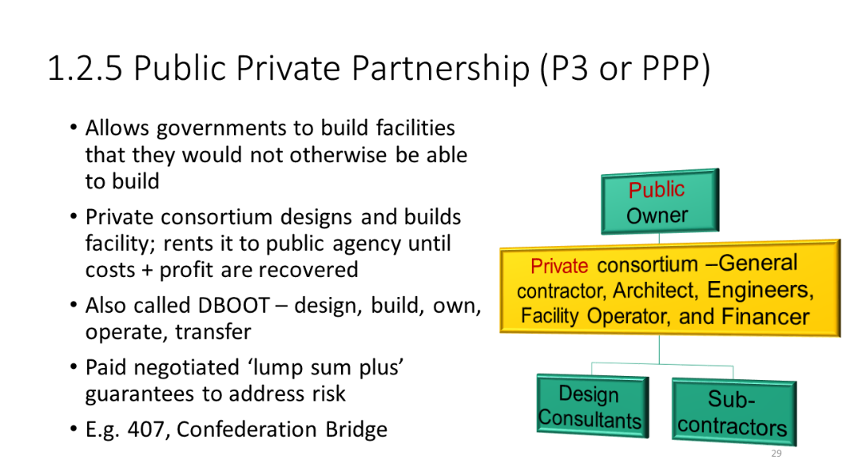
Storyline Text
Fast Track – Public Private Partnership (P3 or PPP)
Storyline Visuals/Animation |  | Storyline Interactivity
- Public private partnership project management structure diagram
- 407 photo
- Confederation Bridge photo
Voice-over Script
The final fast track procurement strategy is Public Private Partnership, referred to as P3 or PPP. This strategy gives governments the ability to build facilities that they otherwise would not be able to build. In this strategy, a private consortium designs and builds the facility, and rents it to a public agency until the costs and profit are recovered. PPP is also known as DBOOT, which is an acronym for design, build, own, operate, and transfer. The contractor is paid a negotiated “lump sum plus” which is guaranteed to address risk.

In the Public Private Partnership strategy, the Public Owner is at the top of the project management structure and establishes ta contractual relationship with the Private Consortium, consisting of the General Contractor, the Architect, Engineers, the Facility Operators, and the Financer. The Private Consortium then hires and manages the contracts with the design consultants and sub-contractors.

Examples of PPP projects are the 407 Express Toll Route Highway in the Greater Toronto Area and the Confederation Bridge.
Questions and Comments

Comparison of PPP and Traditional Procurement

Slide # | 30 | Content Slide
Slide Type | Content | 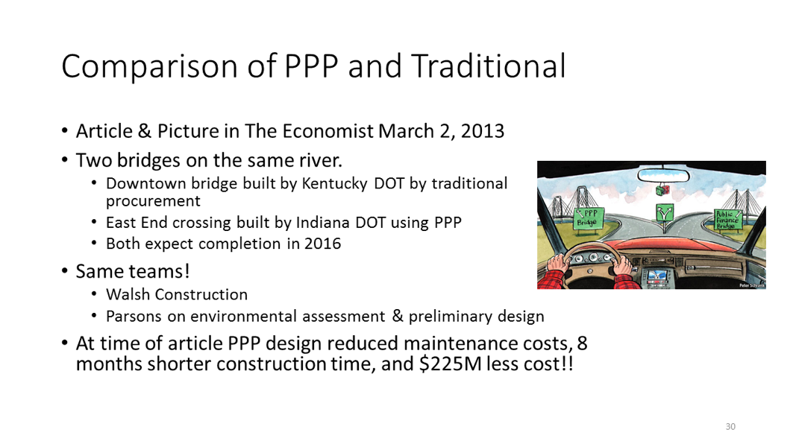
Storyline Text
Storyline Visuals/Animation |  | Storyline Interactivity
- Pictures of the two bridges (Kentucky/downtown and Indiana/east end) under construction
Voice-over Script
An article in The Economist on March 2nd, 2013 compared the construction of two bridges on the same river. The Downtown bridge, built by the Kentucky Department of Transportation, used a traditional procurement strategy, and the East End Crossing, built by the Indiana Department of Transportation used PPP. Both bridges had an expected completion date of 2016. Both bridges were also built by the same teams: Walsh Construction and Parsons, which did the environmental assessment and preliminary design. At the time of the article, the PPP design had lower maintenance costs, an 8-month shorter construction time, and 225 million dollars less cost.
Questions and Comments

Innovation in PPP

Slide # | 31 | Content Slide
Slide Type | Content | 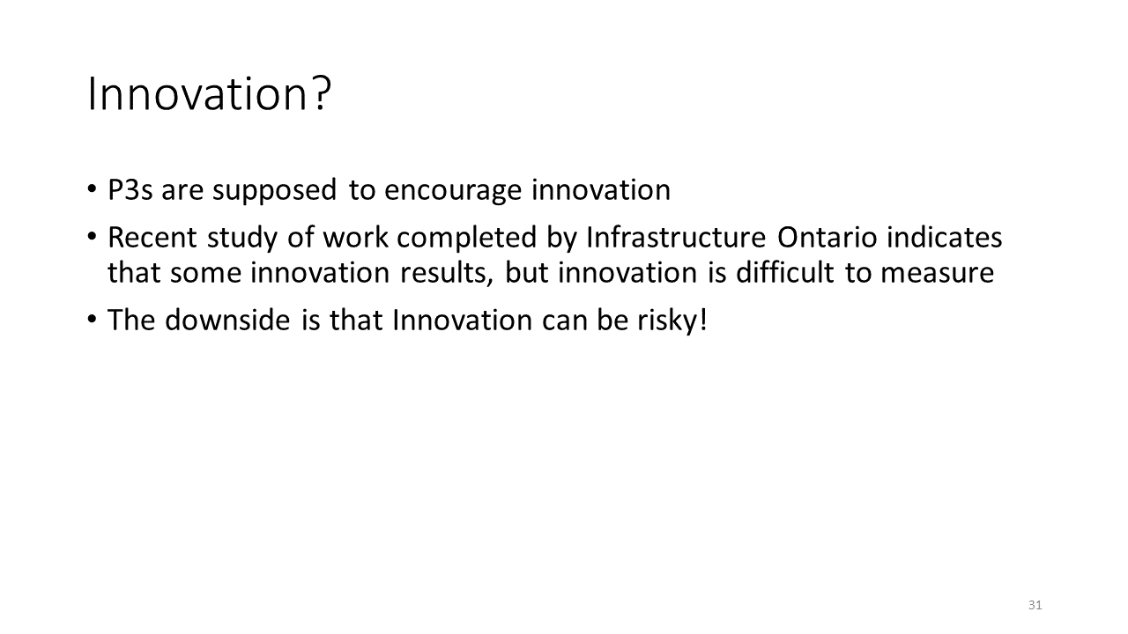
Storyline Text
Storyline Visuals/Animation |  | Storyline Interactivity
Voice-over Script
P3s are supposed to encourage innovation. A recent study of work completed by Infrastructure Ontario indicates that some innovation results, but innovation is difficult to measure. The downside is that innovation can be risky.
Questions and Comments

1.2.6 Alliancing

Alliancing

Slide # | 32 | Content Slide
Slide Type | Content | 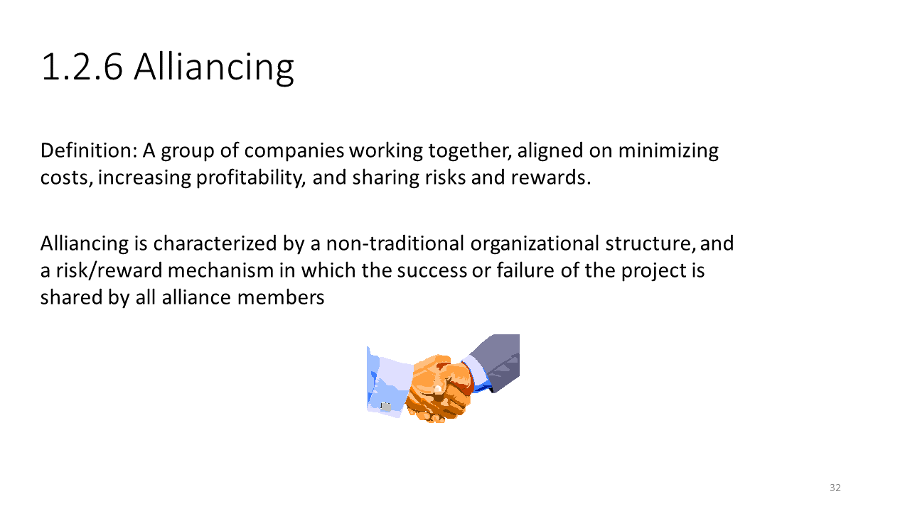
Storyline Text
Alliancing
Storyline Visuals/Animation |  | Storyline Interactivity
Voice-over Script
The next procurement strategy we’ll look at is called Alliancing. An alliance is a group of companies who work together on minimizing costs, increasing profitability, and sharing risks and rewards. Alliancing entails non-traditional organizational structure, and a risk/reward mechanism in which the success or failure of the project is shared by all alliance members.
Questions and Comments

Alliancing Details

Slide # | 33 | Content Slide
Slide Type | Content | 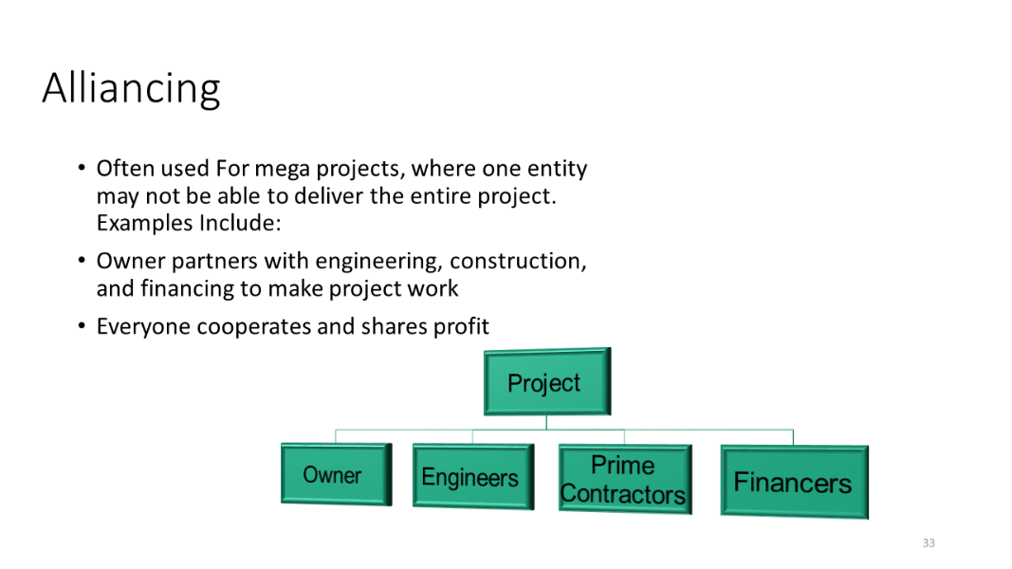
Storyline Text
Storyline Visuals/Animation |  | Storyline Interactivity
- Alliancing project management structure diagram
Voice-over Script
Alliancing is often used for mega projects, where one entity may not be able to deliver the entire project. For example, an owner may partner with engineering, construction, and financing firms in order to make a project work. Everyone in the alliance cooperates and they all share in the profits.

In the Alliancing strategy, the Owner, Engineers, Prime Contractors, and Financers are all of equal standing in the project management structure.
Questions and Comments

Alliancing Examples

Slide # | 34 | Content Slide
Slide Type | Content | 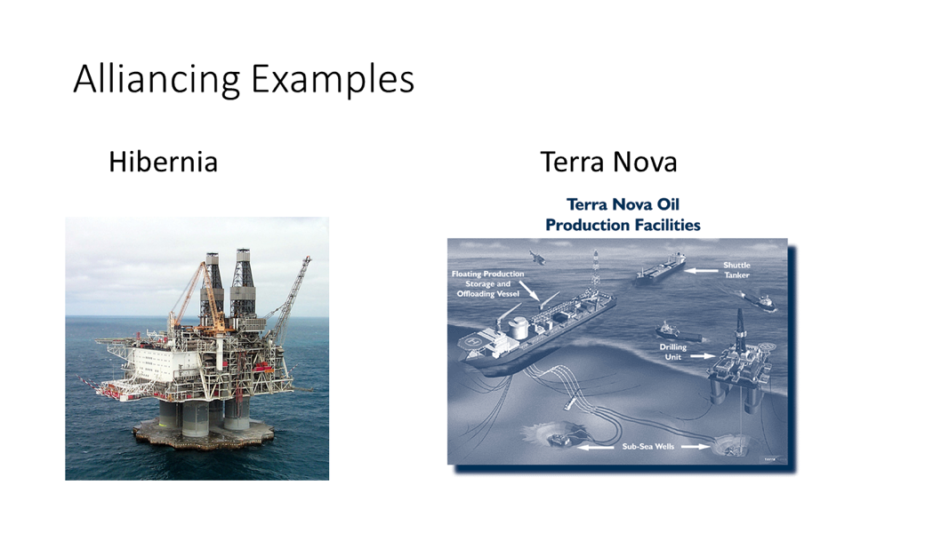
Storyline Text
Storyline Visuals/Animation |  | Storyline Interactivity
- Hibernia photo
- Terra Nova oil photo
Voice-over Script
Examples of Alliancing projects are the Hibernia oil platform, and the Terra Nova Oil Production Facilities.
Questions and Comments

Alliancing Lessons Learned from Successes

Slide # | 35 | Content Slide
Slide Type | Content | 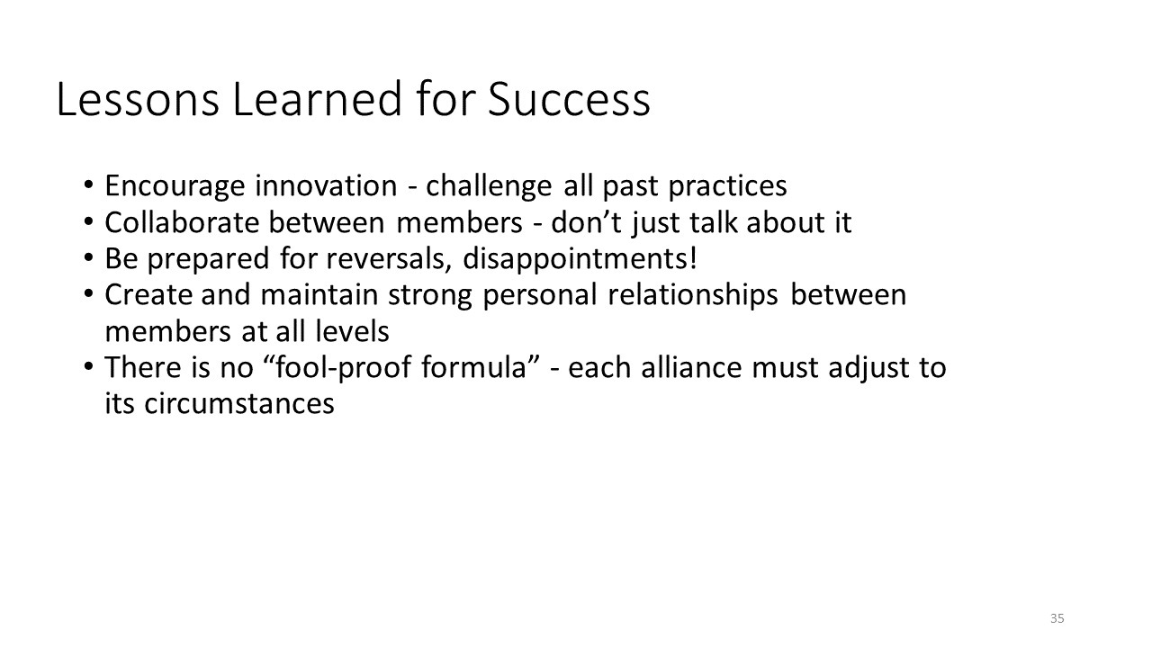
Storyline Text
Storyline Visuals/Animation |  | Storyline Interactivity
Voice-over Script
The alliancing strategy can encourage innovation by challenging all past practises. In order to be successful, alliancing requires active collaboration between members. Teams should be prepared for reversals and potential disappointments. It is important to create and maintain strong personal relationships between members of all levels. Unfortunately, there is no “fool-proof formula.” Each alliance must adjust to its circumstances.
Questions and Comments
- Could this be renamed to something like “advantages” to use more consistent language throughout the unit?

Alliancing Lessons Learned from Failures

Slide # | 36 | Content Slide
Slide Type | Content | 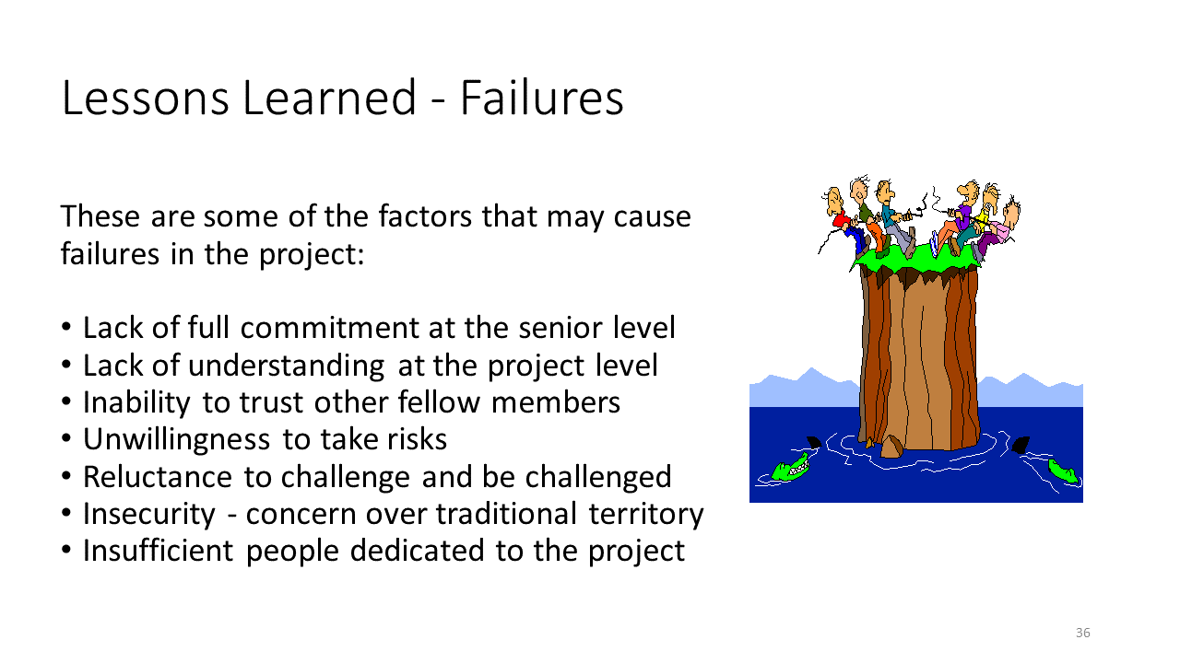
Storyline Text
Storyline Visuals/Animation |  | Storyline Interactivity
Voice-over Script
There are a number of factors that may cause failure in an Alliancing project, including a lack of full commitment at the senior level, a lack of understanding at the project level, an inability to trust other fellow members, an unwillingness to take risks, reluctance to change and be challenged, insecurity and concern over traditional territory, and insufficient people dedicated to the project.
Questions and Comments
- Could this be renamed to something like “disadvantages” to use more consistent language throughout the unit?

1.2.7 Speculative Development

Speculative Development

Slide # | 37 | Content Slide
Slide Type | Content | 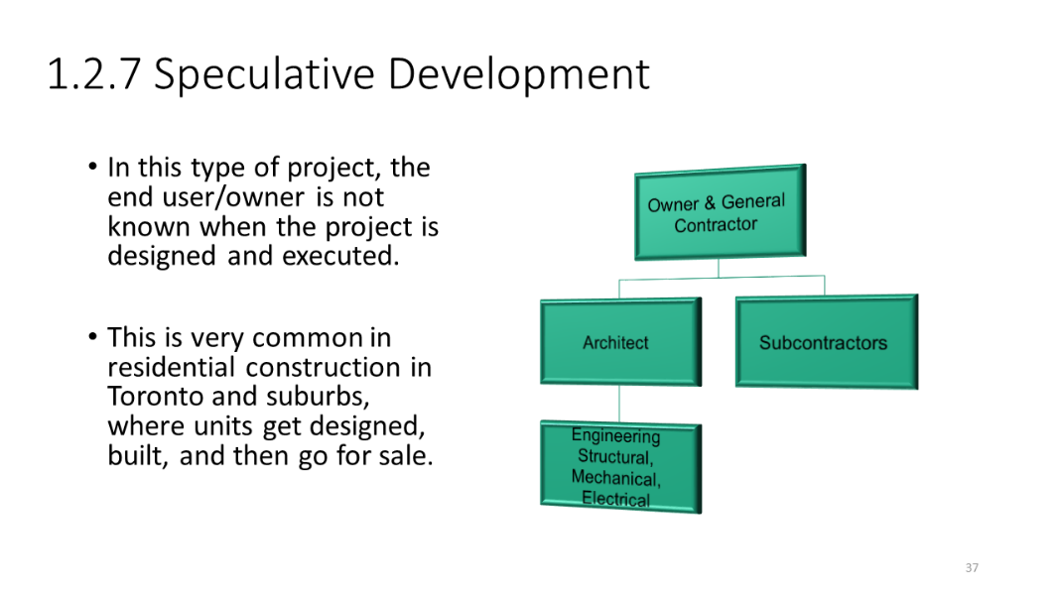
Storyline Text
Speculative Development
Storyline Visuals/Animation |  | Storyline Interactivity
- Speculative development project management structure diagram
- Residences/residential construction photos
Voice-over Script
The final procurement strategy is called Speculative Development. In this type of project, the end user and owner is not known when the project is designed and executed. This is very common in residential construction in Toronto and suburbs, where units are designed and built, before going for sale.

In the Speculative Development strategy, the Owner and General Contractor are at the top of the project management structure, which get into contractual relationships with the architect and the subcontractors. The architect then typically manages the contracts with the structural, mechanical, and electrical engineering teams..
Questions and Comments

1.2.8 Formative Assessment?

Formative Assessment?

Slide # |  | Content Slide
Slide Type | Assessment?
Storyline Text
Storyline Visuals/Animation |  | Storyline Interactivity
Voice-over Script
Questions and Comments

